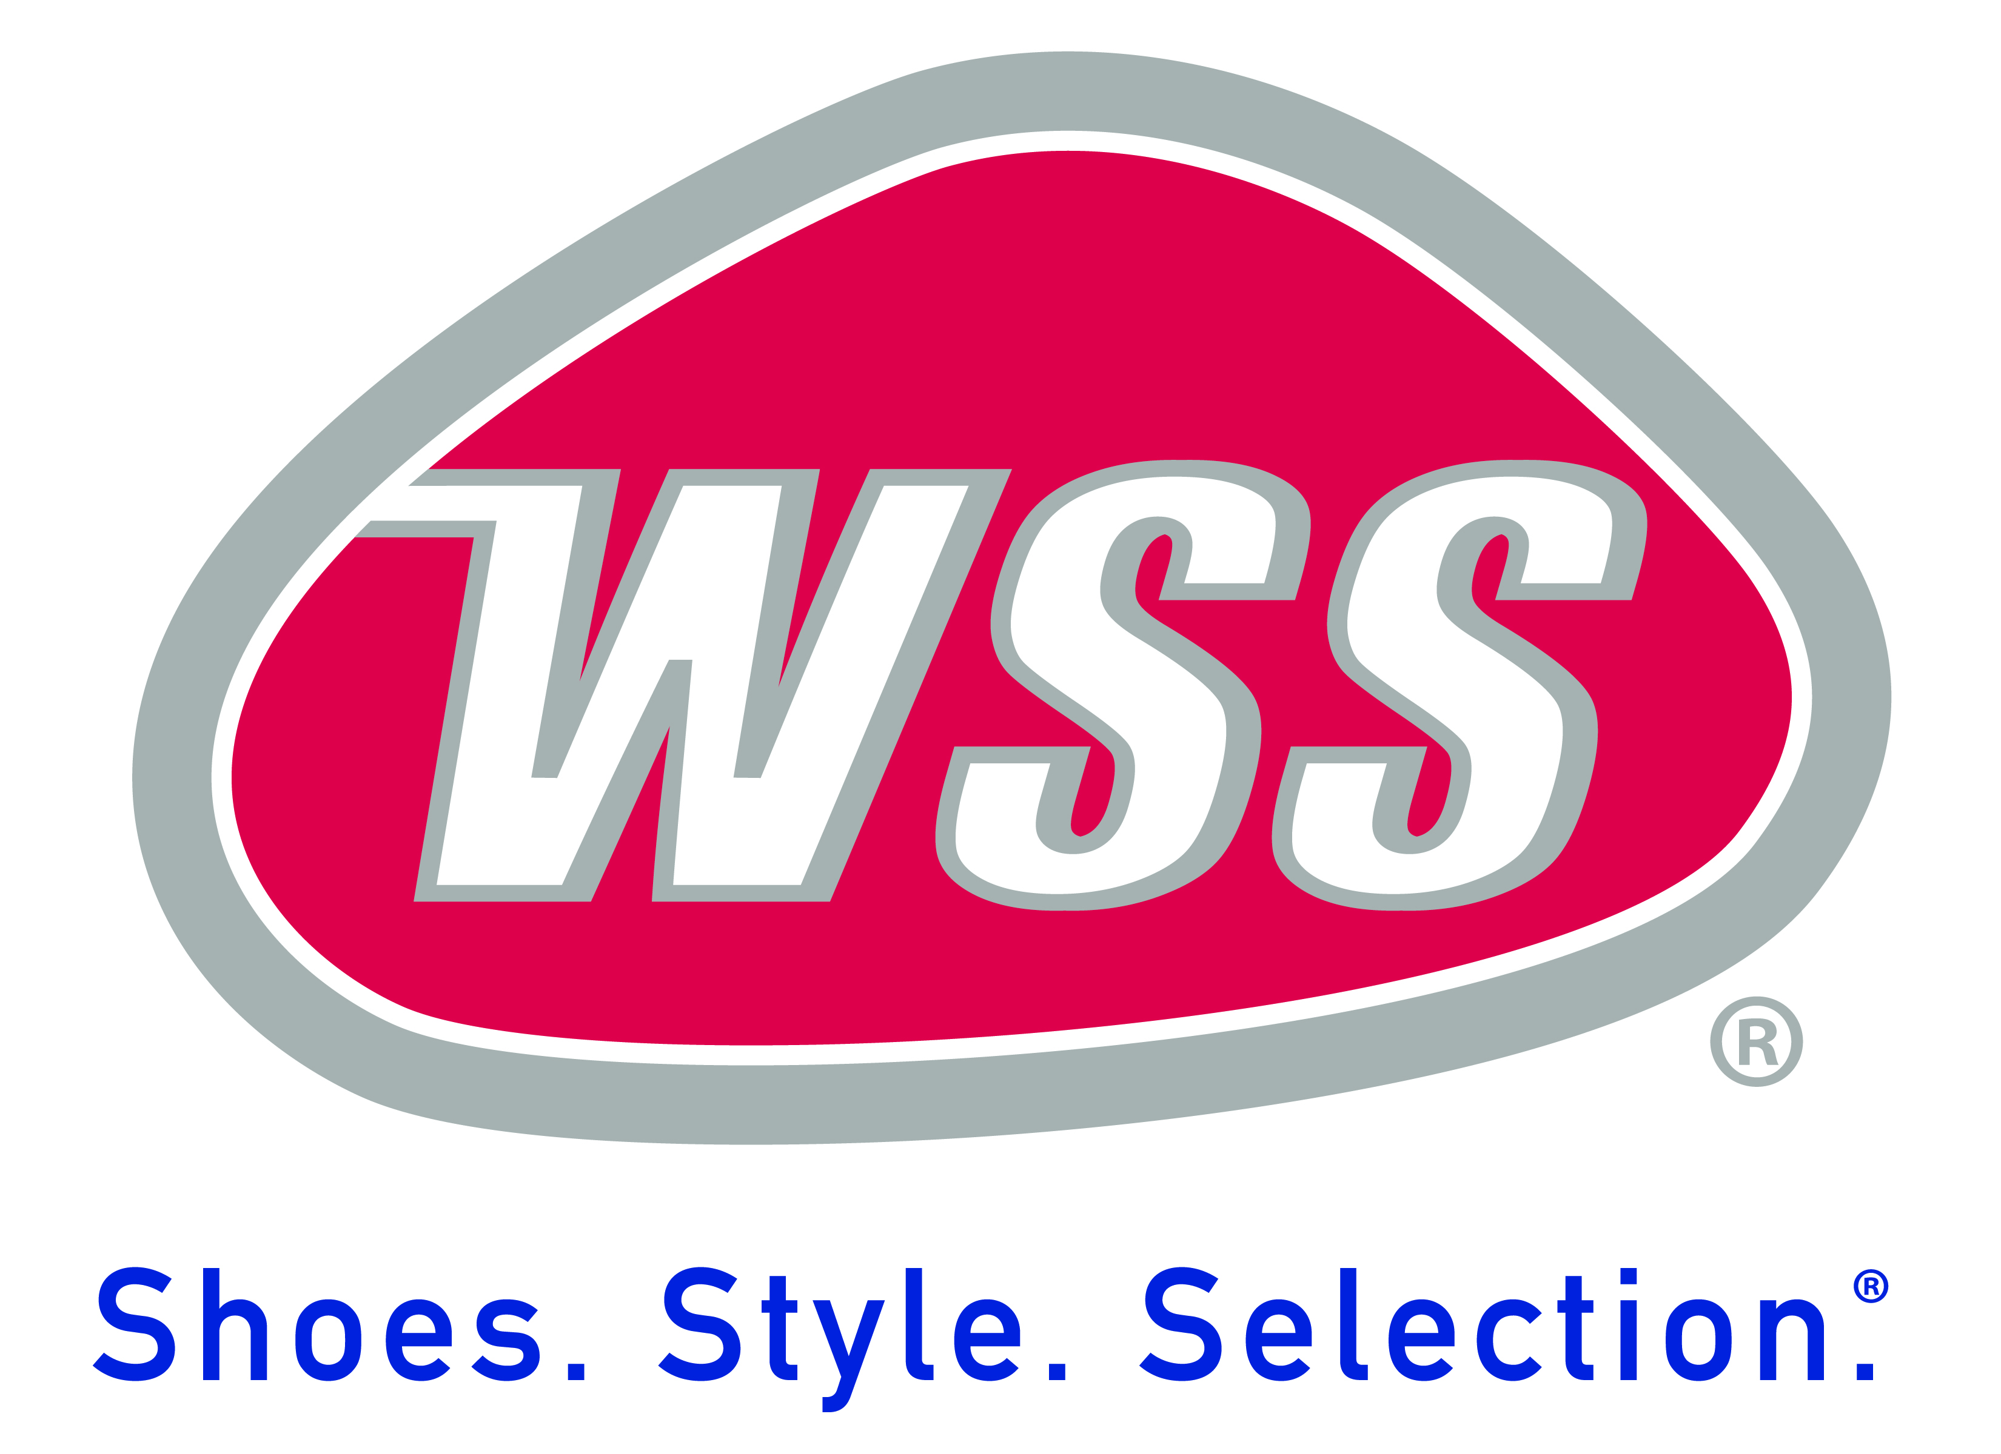
Job Description

Job Title: Marketing Coordinator | Location: LA/Houston/Dallas/Miami
Department: Marketing | Revision Date: April 5, 2023
Reports to: Senior Marketing Manager (SMM) | FLSA Status: Non-exempt (hourly)

POSITION OVERVIEW:
The Marketing Coordinator (MC) is a cross-functional position responsible for the external promotional execution of WSS and our retail brand partners by maximizing our current partnerships and collaborations to sustain as well as improve retention with our core consumer to positively impact sales. The MCs will impact the brand by recognizing relevant district wide opportunities to obtain new consumers. The position will also collaborate and liaise with the Event Planner and Event Coordinators, District Manager and Retail Store leadership. The MC will also work on special marketing projects and/ be assigned key team roles (such as MA Lead) as designated by the Senior Marketing Manager (SMM). Typical work week hours will vary.

ESSENTIAL DUTIES AND RESPONSIBILITIES:
- Maintain an efficient alliance with store operations to effectively drive sales and consumer foot traffic to their designated WSS retail locations.
- Serve as a WSS Brand Ambassador for all events and activations (brand, community and vendor related).
- Work and partner closely with the EP and SMM for large scale marketing events, activations, and promotions.
- Source WSS retail district specific events, activations and promotions that are relevant to brand and core consumer groups.
- Manage and distribute marketing communications at various approved events and activations.
- Conduct market research activities as directed by the EP and/ SMM.
- Serves as Point-of- Contact (POC) for both external and internal vendor partners of approved WSS district events and activations.
- Create event recaps.
- Assist with all equipment load-up, set-up and break-down (with the ability to lift over 50lbs safely with proper equipment)
- Manage and maintain all promotional team equipment including, but not limited to, booths, banners, store products, team vehicles, DJ system, computer systems, audio/visual system, etc.
- Maintain effective inventory control of promotional gifts collected as well as utilized for events activations. This includes premium items such as signed memorabilia.

QUALIFICATION REQUIREMENT
To perform this job successfully, an individual must be able to perform each essential duty satisfactorily. The requirements listed above are representative of the knowledge, skill and/or ability required. Reasonable accommodations may be made to enable individuals with disabilities to perform the essential functions.

EDUCATION and/or EXPERIENCE REQUIREMENTS:
- Ideally 1-2 years of experience with a marketing and/or promotional team.
- High School diploma or equivalent required.
- Experience in Microsoft Excel, Word, and email software a must.
- Must have a clean driving record and valid Driver’s license.
- Minimal event planning and execution preferred.
- High aptitude for social media platforms
- Must have a positive attitude.
- Must be willing to work evenings, weekends, and holidays.

LANGUAGE SKILLS:
- Excellent verbal and written communication skills in English.
- Excellent interpersonal skills.
- Bi-lingual candidate is ideal.
- Ability to utilize, apply, and understand basic retail math concepts (addition, subtraction, multiplication, division, and percentages).

OTHER SKILLS and ABILITIES:
- Effectively update or create new content that falls in line with our content strategy.
- Proactive and determinative nature that evokes an entrepreneurial spirit.
- Basic computer skills that include use of spreadsheets, documents, and multiple internal programs
- An aptitude for the ability to analytical skills including demonstrative skills in handling many assignments simultaneously.
- Precise attention to detail
- Is a cooperative and dedicated team player.
- Strong ability to prioritize and work independently.
- Excellent organizational skills and ability to manage multiple projects at the same time.
- A basic understanding and high yielding desire to increase knowledge base of marketing dynamics, customers, and requirements.
- Able to work in a high stress environment while maintaining composure.
- Moderate technical skills and ability to use web resources.
- Thorough knowledge about products, brands, and company’s strategy
- Must be able to conceptualize creative ideas in promoting products and/or brands.
- Ability to identify marketing opportunities and exercise judgment to take advantage of those opportunities.

Physical Demands and Work Environment:
The physical demands described here a representative of those that must be met by an employee to successfully perform the essential functions of this job. The employee must be able to:
- Bend and twist at the waist, stoop, crouch, crawl, climb, balance, kneel, or squat while maneuvering boxes into placed as needed.
- Stand or walk at least 8 (eight) hours each day.
- Lift up to 50lbs. from ground level to above shoulders repeatedly over the course of the shift
- Climb a step stool or ladder.
- Communicate effectively in person and on the phone.

ABOUT WSS:
WSS is the premier footwear retailer in the U.S. doing business in neighborhood-based stores. Consumers trust WSS for the best brands, greatest values, and largest selection of athletic, dress, fashion, and casual footwear for the entire family. Our large store format enables us to showcase thousands of styles from top name brands like Nike, Jordan, Vans, Converse, Adidas, Puma, Skechers, etc. In addition, WSS carries high quality private brands augmenting the breadth of selection to deliver amazing value to our customers.

Stay connected to us via Facebook, Instagram, and Twitter and at www.shopwss.com.

