City of Hoboken

Department of Community Development

2023 Community Development Block Grant

REQUEST FOR FUNDING APPLICATION

Application Deadline: Friday, February 24, 4:00PM

Project Name: Click or tap here to enter text.
Applicant: Click or tap here to enter text.

The City of Hoboken Department of Community Development reserves the right to reject any application that is not complete in accordance with the following instructions.

Introduction
In 1974, the federal government enacted the Federal Housing and Community Development Act. Title I of the Act combined several funding programs into a single program called “Community Development Block Grant” (CDBG). Congress designed the CDBG program to enhance and maintain the viability of urban communities. The CDBG program accomplishes these goals by providing decent housing, suitable living environments and expanded economic opportunities principally for low and moderate income households. The U.S. Department of Housing and Urban Development (HUD) administers the CDBG program through state and local governments, like the City of Hoboken.
Communities receiving CDBG block grants develop their own programs and funding priorities based on local community development needs. The City of Hoboken is offering local organizations a chance to apply for a portion of its 2023 Community Development Block Grant funds. There are two categories of funds available:
- Public Services. This funding category supports local programs that provide direct service to low and moderate-income residents of Hoboken. The overall budget for this category is limited by federal regulation to just 15% of the CDBG annual budget (approximately $150,000).
- Capital Improvements. This category provides local nonprofits with assistance in making capital improvements to facilities that directly serve low and moderate-income. Potential projects include ADA renovations, energy efficiency improvements, correcting code violations and more. Approximately $600,000 will be available for projects in this category.
If you are a first-time applicant or applied previously and were unsuccessful, it is strongly recommended that you take advantage of technical support from our CDBG Consultant. Marc Leckington of Triad Associates can help make sure your project is CDBG-eligible and answer any questions about the program and the application process. He can be reached at mleckington@triadincorporated.com or 856-481-7040.

Application Requirements
The application must be filled out in its entirety with all attachments and exhibits completed and submitted by the due date. If the applicant fails to submit the application by the announced due date, the application will not be accepted. Any application form that has been altered will be rejected and returned. Incomplete applications will also be returned and given a one (1) week period to cure. Any attachments that are not requested in the application will not be considered in the ranking of your application. The attachments must have a cover page stating the applicant’s name and attachment number stated on the application form.
A separate application is required for each project or activity. In addition, only typed applications will be accepted.

Program Guidelines
Federal regulations define the parameters for using CDBG funds according to national objectives. They also specify eligible program activities. Copies of these regulations are available on HUD’s website at: https://www.hudexchange.info/programs/cdbg-entitlement/.
Eligible activities include acquisition of real property for an eligible use, construction and rehabilitation of public facilities, demolition and clearance of deteriorated buildings, community services for persons or households earning less than 80% of Area Median Income by Family Size, removal of barriers that restrict the mobility of elderly and the mobililty impaired, and special economic development activities.
Ineligible activities include the construction of religious facilities or government buildings, new housing construction, equipment purchases, municipal maintenance and operation expenses, political or religious proselytizing, and fundraising.
City of Hoboken staff will review all proposals for eligibility and rate them based on their consistency with the CDBG National Objectives and the strategies and goals of the adopted 2020-2024 Consolidated Plan. Approved proposals and their evaluations will be forwarded to the City of Hoboken CDBG Subcommittee for funding priority ranking/recommendations. A copy of the 2020-2024 Consolidated Plan can be along with other documents on the City’s CDBG webpage: https://www.hobokennj.gov/resources/community-development-block-grant-program.

Program Goals
The City of Hoboken will fund applicants who exemplify the capacity to promote quantifiable benefits to low and moderate-income households within the City of Hoboken, to eliminate and prevent slums and blight, and in times of emergency, address the urgent needs of the City.

Section 1: Applicant and Project Information

- Name of Applicant: Click or tap here to enter text.
(2) Address: Click or tap here to enter text.
(3) Contact Person: Click or tap here to enter text.
Title: Click or tap here to enter text.
Phone: Click or tap here to enter text.
Email: Click or tap here to enter text.
(4) Type of Organization:
☐ Not-for-Profit ☐ Public Agency ☐ Other (Please Specify) Click or tap here to enter text.
(5) UEI Number (required): Click or tap here to enter text.
(6) Proposed Activity -- Select the activity that most accurately describes your project:
Choose an item.
If Other, please describe your proposed Activity: Click or tap here to enter text.
(7) Requested CDBG Funds: $Click or tap here to enter text. | Total Project Cost: $Click or tap here to enter text.
(8) Name of Proposal:Click or tap here to enter text.
Primary address of proposed activity:Click or tap here to enter text.
Census Tract: Click or tap here to enter text.
Block Group: Click or tap here to enter text.
(9) Brief Proposal Description: Click or tap here to enter text.

Section 2: Proposal Details
(1) Identify location of Project/Program: Click or tap here to enter text.
(2) Project Objective: Choose an item.
(3) Project Outcome: Choose an item.
(4) Is this activity new, or ongoing? Choose an item.
(5) Please provide a brief description of the proposed project or program below, and using only the space provided. Click or tap here to enter text.

Section 3: Documentation of Community Need
Please answer each of the questions in the space provided below. This section should not exceed two pages.
(1) Provide evidence of the need for this program, serving low, very low and extremely low income households, individuals, or areas within the City of Hoboken. Specific information should be included related to the needs of the population, area being served, and connection to the proposed activity.
Click or tap here to enter text.
(2) Identify the populations that will benefit from the proposed activity, and provide clear data demonstrating that the proposed activity will serve an identified need in the community.
Click or tap here to enter text.
(3) Provide an explanation of how this activity is not a duplication of other projects/programs in the area, how this activity will fill current gaps in the system, and also where efforts have been made to coordinate and develop partnerships with programs providing similar services in the area.
Click or tap here to enter text.

Section 4: Proposed Performance Goals
Please answer each of the questions in the space provided below. This section should not exceed two pages.
(1) Following the guidelines below, establish quantitative and qualitative goals that can be used to judge the effectiveness of the proposed activity.
- Set numerical performance goals (i.e. how many persons served, time frames, etc.).
Click or tap here to enter text.
- Explain why specific measurements were chosen to measure performance.
Click or tap here to enter text.
- Provide a schedule showing how your agency will measure its progress in achieving these goals on a quarterly basis.
Click or tap here to enter text.

Section 5: Applicant Capacity
Please answer each of the questions provided below. This section should not exceed two pages.
(1) Describe the applicant and/or administrator of the proposed project/program by answering the following:
(a) Brief history of the applicant, including length of existence.
Click or tap here to enter text.
(b) Identify current services offered and special accomplishments and skills that will demonstrate your organization’s ability to undertake the proposed activity.
Click or tap here to enter text.
(c) List any previous experience the applicant has had that would be relevant to the proposal.
Click or tap here to enter text.
(d) List any prior experience with Community Development Block Grant Funding.
Click or tap here to enter text.
(e) Describe how your organization will handle the record-keeping required by this type of funding (i.e., proof of income eligibility).
Click or tap here to enter text.
2. Identify the staff that will be assigned to this project or program, and answer the items below:
- Are the identified positions currently staffed, will a new staff member be hired, or will additional staffing considerations be obtained through contracting?
Click or tap here to enter text.
- Estimate the amount of time that the identified staff will spend on tasks related to this activity on a weekly basis.
Click or tap here to enter text.
- Identify the key staff roles related to this activity, and the expertise they will bring in order to implement this proposal.
Click or tap here to enter text.
3. How quickly will the project begin, once funds are awarded?
Click or tap here to enter text.
4. Identify community demand for the proposed project (i.e., Letters of support from community members, community organizations, elected officials, etc.)
Click or tap here to enter text.

Section 6: Budget
(1) Please complete all applicable worksheets and submit the budget spreadsheet (“CDBG 2021 Application Budget.xls”) as an attachment to this application.
(2) Cost Effectiveness
(a) Can this program/project operate at past levels of effectiveness if Hoboken CDBG funds are not awarded for the full requested amount? ☐Yes ☐No
(b) Describe your plans to use other funds on this program/project. In this section, only describe funds that are secured. Provide the source of funds, amounts, and how these funds will be used.
Click or tap here to enter text.
(3) Budget Narrative. Provide a detailed description of each budget line item for which you are seeking funding.
Click or tap here to enter text.

Section 7: Job Description(s)
To be completed by all applicants proposing to use CDBG funds for wages.
Individual’s Name: Click or tap here to enter text.
Title: Click or tap here to enter text.
Hourly Wage: Click or tap here to enter text. | Hourly Benefits: Click or tap here to enter text.
Job Description: Click or tap here to enter text.

Individual’s Name: Click or tap here to enter text.
Title: Click or tap here to enter text.
Hourly Wage: Click or tap here to enter text. | Hourly Benefits: Click or tap here to enter text.
Job Description: Click or tap here to enter text.

Individual’s Name: Click or tap here to enter text.
Title: Click or tap here to enter text.
Hourly Wage: Click or tap here to enter text. | Hourly Benefits: Click or tap here to enter text.
Job Description: Click or tap here to enter text.

Individual’s Name: Click or tap here to enter text.
Title: Click or tap here to enter text.
Hourly Wage: Click or tap here to enter text. | Hourly Benefits: Click or tap here to enter text.
Job Description: Click or tap here to enter text.

Individual’s Name: Click or tap here to enter text.
Title: Click or tap here to enter text.
Hourly Wage: Click or tap here to enter text. | Hourly Benefits: Click or tap here to enter text.
Job Description: Click or tap here to enter text.

Section 8: Application Certification
I hereby certify that all of the above and attached information is accurate to the best of my knowledge and approve the submission of this application for the City of Hoboken Community Development Block Grant Funds.
Typed Name: Click or tap here to enter text.
Title: Click or tap here to enter text.
Signature:______________________________________ Date: Click or tap to enter a date.
Do not mail any application materials to the City of Hoboken at this time. Instead, email one copy of the signed application (including the budget) and email the Word file of the application along with one Excel file of the budget. As applications are received, Ms. Wolf will confirm receipt via email. However, feel free to use the return receipt or delivery confirmation options in your email software. Applications should be emailed to:
Cathleen Wolf
City of Hoboken
Department of Community Development
94 Washington Street
Hoboken, NJ, 07030
Email: cwolf@hobokennj.gov
If you have any questions concerning the application or the submission requirements, you are encouraged to contact the City’s CDBG Consultant:
Marc Leckington, Senior Associate, Triad Associates
(856) 481-7040
Email: mleckington@triadincorporated.com

Exhibit 1: Scoring Criteria
The City of Hoboken will score applications based on a weighted scale of 100 points and the following criteria. Public service applications that do not benefit at least 51% low, very-low and/or extremely low income persons will not be considered. Public facility applications that do not benefit at least 38.78% will not be considered.

- Activity Need and Justification: Maximum of 20 Combined Points

a. Need: Maximum of 15 Points
The activity will be evaluated in terms of the documentation and justification of the need for the activity. Activities with Excellent documentation and justification will be awarded the maximum of 15 points: Good, 10 points; Average, 5 points; and Poor, 0 points.

b. Consolidated Plan Priority: Maximum of 5 Additional Points
Activities addressing high priorities, as identified in the Consolidated Plan will be awarded 5 points.

- Cost Reasonableness and Effectiveness: Maximum of 10 Points
The activity will be evaluated in terms of: 1) its impact on the identified need; and 2) its implementation costs and funding request relative to its financial and human resources. Evaluation will include the cost incurred per person per unit and the justification for a particular level of funding. Points will be awarded on a scale basis, with the most cost effective programs being awarded 10 points.

- Activity Management and Implementation: Maximum of 30 Points

a. Management: Maximum of 15 Points
Points will be awarded to applicants based on documentation and information provided, showing that the resources needed to manage the proposed activity are available and ready, and that the commitment for operation and maintenance, where applicable, has been certified. In addition, for applicants that have received CDBG funds in the past, their record of maintenance for the funded activity will be evaluated. Activities with Excellent documentation and information will be awarded the maximum of 15 points: Good, 10 points; Average, 5 points; and Poor, 0 points.

b. Implementation: Maximum of 15 Points
Points will be awarded to applicants based on documentation and information provided, showing that the resources, such as funding, site control, etc., needed to implement the proposed activity are available and ready. Maximum points will be given to activities that are ready to move forward quickly. This criterion takes into consideration factors that may accelerate or slow down the ability to implement the activity in a timely manner. Activities with Excellent documentation and information will be awarded the maximum of 15 points: Good, 10 points; Average, 5 points; and Poor, 0 points.

- Experience and Past Performance: Maximum of 10 Points
The experience of the applicant, including the length of time in business and experience in undertaking projects of similar complexity as the one for which funds are being requested will be evaluated.

In addition, the applicant will be evaluated in terms of their past performance in relation to any local, state, or Federal funding program. The past performance will refer to the attainment of objectives in a timely manner and the expenditure of funds at a reasonable rate in compliance with the contract. Compliance with the contract will include but not be limited to submission of reports and adherence to the scope of services.

For those applicants that have not received CDBG funding from the City of Hoboken in the past, allocation of points up to the maximum of 10 points will be awarded, dependent upon thorough documentation of similar past performances submitted with the application.

- Matching Contributions: Maximum of 20 Points
a. Efforts to Secure Other Funding: Maximum of 5 Points
Points will be awarded based on the applicant’s efforts to secure other funding for the activity.

b. Matching: Maximum of 15 Points
Points will be awarded based on the ratio of the amount of eligible matching funds to the amount of CDBG funds requested:

1.1-1 or more 15 points
.75-1 10 points
.50-1 7 points
.25-1 5 points
less than .25 0 points

- Application Completeness: Maximum of 10 Points
Applications will receive up to 10 points based on completeness. Applications that have not been signed will not be considered. Applications submitted with a complete budget and narrative will be considered for the full 10 points. Applications missing lacking details will be considered for 5 points. Applications missing full items will receive 0 points.

Exhibit 2: Eligible Census Block Groups
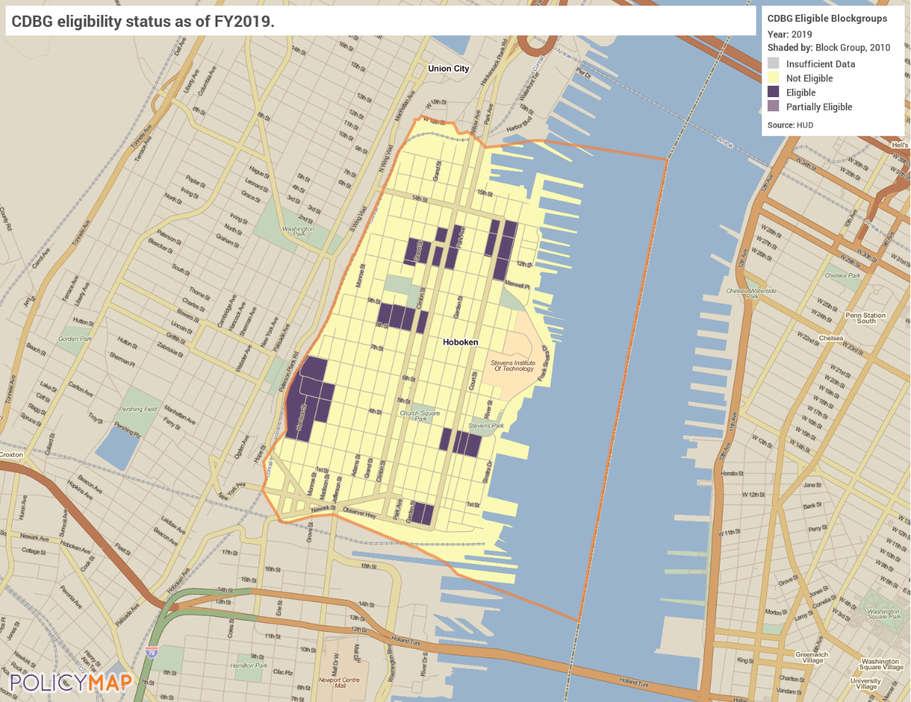

Income Eligibility Summary Data
Listed below are the Census Tracts/Block Groups where at least 38.78% of the residents in a census tract/block group have household incomes of less than 80% of area median income by household size. Income Summary Data supports the CDBG program's National Objective of providing benefits to households earning less than 80% of area median income on an area basis (Low/Moderate Area = LMA). The LMSID are derived from special data tabulations provided to HUD by the U.S. Census Bureau.
Municipality | Eligible  Census Tract | Block  Groups | Low/Mod  Persons | Low/Mod Universe | Low/Mod  Percentage
Hoboken | 018400 | 3 | 590 | 975 | 60.51%
 | 018400 | 4 | 380 | 905 | 41.99%
 | 018500 | 4 | 405 | 765 | 52.94%
 | 018702 | 2 | 450 | 850 | 52.94%
 | 018702 | 4 | 640 | 1,100 | 58.18%
 | 019000 | 1 | 475 | 1,225 | 38.78%
 | 019000 | 3 | 690 | 1,045 | 66.03%
 | 019000 | 4 | 1,255 | 1,355 | 92.62%
 | 019300 | 2 | 480 | 925 | 51.89%
 | 019400 | 1 | 640 | 1,475 | 43.39%

Exhibit 3: City of Hoboken CDBG Performance Measure Indicators
Successful applicants will be required to submit progress reports on a quarterly basis (July-September; October-December; January-March; April-June) with demographics and income information on the number of persons assisted.

Exhibit 4: FY2022 CDBG Income Limits by Household Size

Income Limits | 1 Person | 2 Persons | 3 Persons | 4 Persons | 5 Persons | 6 Persons | 7 Persons | 8 Persons
50% of Area Median Income  (Low Income) | 40,250 | 46,000 | 51,750 | 57,450 | 62,050 | 66,650 | 71,250 | 75,850
80% of Area Median Income  (Moderate Income) | 64,350 | 73,550 | 82,750 | 91,900 | 99,300 | 106,650 | 114,000 | 121,350

