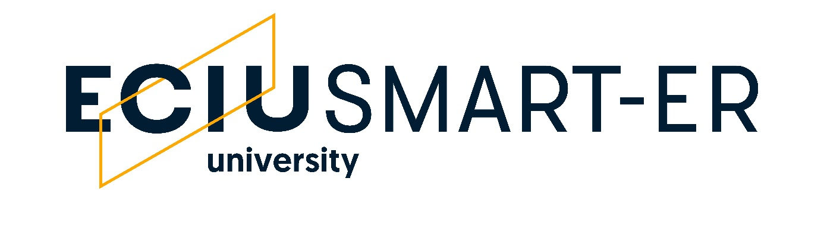

SPA 2 - Blended mobility to create networks

Consensus Form

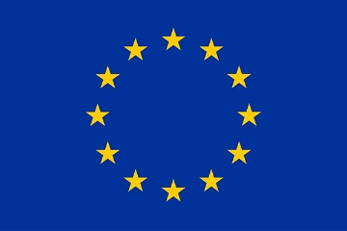
This project has received funding from the European Union's Horizon 2020 research and innovation programme under Grant Agreement #101016888. This result only reflects the author's view and the EU is not responsible for any use that may be made of the information it contains.

Acronym of the proposal:
Coordinator institution:
Reference:

- Excellence  - Quality and credibility of the proposed workplan; including inter/multidisciplinary, intersectoral, engagement of citizens, civil society and end users, gender and ethics aspects  - Quality and appropriateness of knowledge sharing among the participating organisations, including applicable IPR aspects  Comments: | Score 1:  Threshold 3/5  Weighting: 30%

- Impact  - Developing new and lasting research collaborations between participating organisations and contribution to improving research and innovation potential at SMART-ER  - Quality of the proposed measures to disseminate and communicate the results of the action and to promote the recognition and impact of the ECIU University  Comments: | Score 2:  Threshold 3/5  Weighting: 40%

- Implementation  - Appropriateness of the management procedures, including risk management  - Appropriateness of the institutional environment (hosting arrangements, infrastructure)  Comments: | Score 3:  Threshold 3/5  Weighting: 30%
Total score
Threshold 12/15

