SPA 3 – SMART-ER Seed Projects

Consensus Report

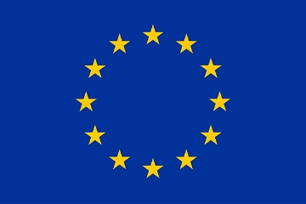
This project has received funding from the European Union's Horizon 2020 research and innovation programme under Grant Agreement #101016888. This result only reflects the author's view and the EU is not responsible for any use that may be made of the information it contains.

Scoring
- — Poor. The criterion is inadequately addressed, or there are serious inherent weaknesses.
- — Fair. The proposal broadly addresses the criterion, but there are significant weaknesses.
- — Good. The proposal addresses the criterion well, but a number of shortcomings are present.
- — Very Good. The proposal addresses the criterion very well, but a small number of shortcomings are present.
- — Excellent. The proposal successfully addresses all relevant aspects of the criterion. Any shortcomings are minor.
Thresholds & weighting
The final score will be calculated as the sum of the individual assessments provided by the Evaluators. The default threshold for individual criteria (Excellence, Impact and Implementation) is 3. The default overall threshold (the weighted sum of the three individual scores) is 12.

- Excellence  - Quality of the proposed research and innovation plan  - Clarity and pertinence of the objectives  - Appropriate consideration of interdisciplinary approaches, use of stakeholder knowledge and, where applicable, engagement of citizens, civil society and end users, IPR and ethics issues and gender dimension in research and innovation content  Comments: | Score 1:  Threshold 3/5  Weighting: 30%

- Impact  - Where applicable, the relevance of the identified challenge  - The extent to which the outputs of the project would contribute to each of the expected impacts of the challenge and beyond  - The extent to which the outputs of the project would contribute to each of the expected impacts of the challenge and beyond  Comments: | Score 2:  Threshold 3/5  Weighting: 40%

- Implementation  - Quality and effectiveness of the workplan, including extent to which it is in line with their objectives  - Consideration of potential risks and quality of contingency plans  - Complementarity of the participants  Comments: | Score 3:  Threshold 3/5  Weighting: 30%
Total score
Threshold 12/15

